Project Planning Phase
Project Planning Template (Product Backlog, Sprint Planning, Stories, Story points)

Date | 15 February 2026
Team ID | LTVIP2026TMIDS24941
Project Name | ToyCraft Tales: Tableau's Vision into Toy Manufacturer Data
Maximum Marks | 8 Marks

Product Backlog, Sprint Schedule, and Estimation (4 Marks)
Use the below template to create product backlog and sprint schedule

Sprint | Functional Requirement (Epic) | User Story Number | User Story / Task | Story Points | Priority | Team Members
Sprint-1 | Registration | USN-1 | As a user, I can register for the application by  entering my email, password, and confirming my password. | 2 | High | 1,4
Sprint-1 | User Confirmation | USN-2 | As a user, I will receive confirmation email once I have registered for the application | 1 | High | 2,3
Sprint-2 | Social Login | USN-3 | As a user, I can register for the application through Facebook | 2 | Low | 3
Sprint-1 | Social Login | USN-4 | As a user, I can register for the application through Gmail | 2 | Medium | 2
Sprint-1 | Login | USN-5 | As a user, I can log into the application by entering email & password | 1 | High | 1
Sprint-2 | Dashboard | USN-6 | As a user, I can interact with the toy trend dashboard using filters. | 3 | High | 4
Sprint-2 | Survey Submission | USN-7 | As a user, I can submit my toy preferences via survey form. | 2 | Medium | 2,3
Sprint-3 | Dashboard Export | USN-8 | As a user, I can download dashboard charts in PDF/PNG. | 2 | Medium | 1
Sprint-3 | Admin Data Upload | USN-9 | As an admin, I can upload and refresh sales data on the dashboard. | 3 | High | 4

Project Tracker, Velocity & Burndown Chart: (4 Marks)

Sprint | Total Story Points | Duration | Sprint Start Date | Sprint End Date (Planned) | Story Points Completed (as on Planned End Date) | Sprint Release Date (Actual)
Sprint-1 | 20 | 1 Days | 22 June 2025 | 30 June 2025 | 20 | 22 June 2025
Sprint-2 | 20 | 6 Days | 22 June 2025 | 30 June 2025 | 20 | 30 June 2025
Sprint-3 | 20 | 6 Days | 22 June 2025 | 30 June 2025 | 20 | 30 June 2025
Sprint-4 | 20 | 6 Days | 22 June 2025 | 30 June 2025 | 20 | 30 June 2025

Velocity:
Imagine we have a 10-day sprint duration, and the velocity of the team is 20 (points per sprint). Let’s calculate the team’s average velocity (AV) per
iteration unit (story points per day)
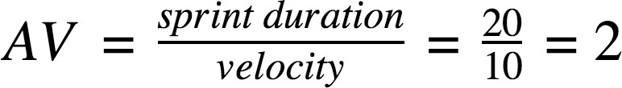

Burndown Chart:

A burn down chart is a graphical representation of work left to do versus time. It is often used in agile software development methodologies such as Scrum. However, burn down charts can be applied to any project containing measurable progress over time.

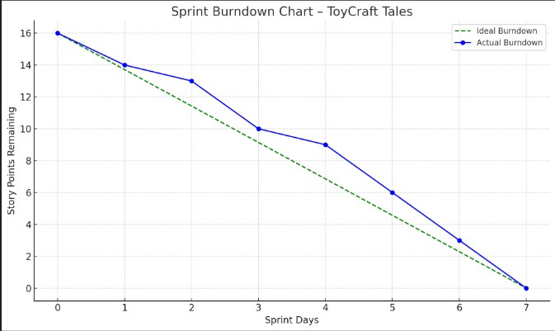
https://www.visual-paradigm.com/scrum/scrum-burndown-chart/ https://www.atlassian.com/agile/tutorials/burndown-charts

Reference:
https://www.atlassian.com/agile/project-management https://www.atlassian.com/agile/tutorials/how-to-do-scrum-with-jira-software https://www.atlassian.com/agile/tutorials/epics https://www.atlassian.com/agile/tutorials/sprints https://www.atlassian.com/agile/project-management/estimation https://www.atlassian.com/agile/tutorials/burndown-charts

